**SOP for –**Installing Nagios in a server..docx

|  |  |
| --- | --- |
| SOP ID | Installing Nagios in a server.docx |
| Developed By |  |
| Reviewed & Approved By |  |
| Published on | 29-1-2019 |
| ☐ Generic.             ☒ Infra Specific -yes.             ☐ Customer Specific.               ☒ Platform Specific.                            ☐ OS Specific | |

|  |  |
| --- | --- |
| Tags (for KB search) | Azure, Server, RDP |
| Keywords (for KB search | RDP, access |

**Dependencies:**

|  |  |
| --- | --- |
| **With Customer / App vendor** | **With Service Provider** |
|  |  |

**Possible problems you may encounter in executing it and solution/workaround for the same**

|  |  |
| --- | --- |
| **Problems** | **Solution / Workaround** |
|  |  |
|  |  |
|  |  |
|  |  |

**How to validate successful implementation:**

|  |  |  |  |  |
| --- | --- | --- | --- | --- |
| S.No. | Process Step | Dependent Activities / Process Step | Referenced Document / Screenshot | Verification |
| 1 | Remote into the server in which the we need to install the Nagios. |  |  |  |
| 2 | Copy the Nagios setup file to the respective server. |  |  |  |
| 3 | Double click on the setup file NRDS_Win_64 and run as Administrator. |  | Figure1 |  |
| 4 | Select the ”I Agree”on the license agreement. |  | Figure2 |  |
| 5 | Provide the requested information. |  | Figure3 |  |
| 5 | Click on Next |  | Figure4 |  |
| 6 | Mention the destination location where the Nagios need to be installed and select Install. |  | Figure5 |  |

Figure1: Double click on the setup file NRDS_Win_64

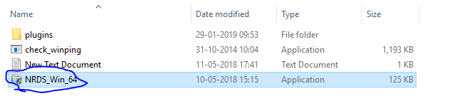

Figure2: Select ”I Agree “

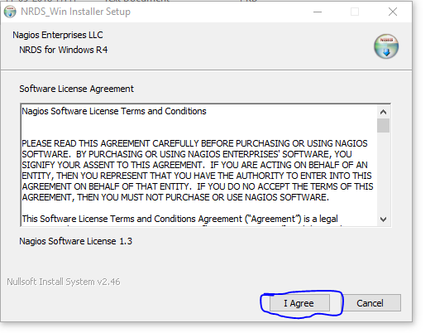

Figure3: Provide the requested information.

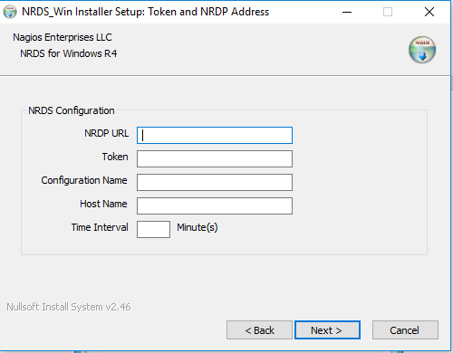

Figure4: Click on Next

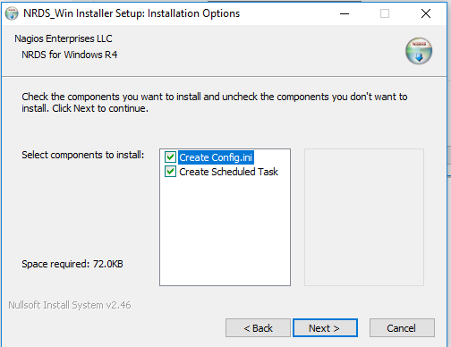

Figure5: Mention the destination location where the Nagios need to be installed and select Install.

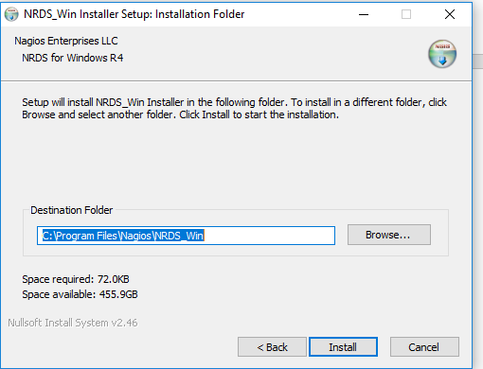

*Change History*

|  |  |  |  |  |
| --- | --- | --- | --- | --- |
| **Ver. No.** | **Modified Date** | **Modification Details** | **Reason****for Modification** | **Modified By** |
| 1.0 | 26-12-2018 | Initial version | To standardize | Abhishek |